**SPEAKER SUMMARY**

**July 2024**

**ARAM BENYAMIN, DWP CHIEF OPERATING OFFICER**

**ORGANIZATIONAL UPDATE**

**By Robert Yoshimura**

Aram Benyamin is a long-time DWP employee who recently returned from an

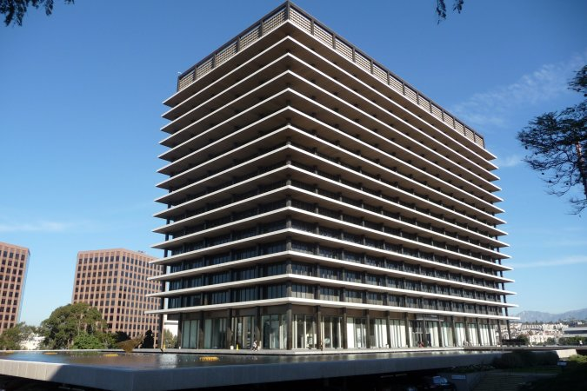

eight-year stint as CEO of Colorado Springs Utilities which provides a broad range of public services including water, wastewater, power, and gas. Aram accepted the role of COO nearly two years ago and has been focused on organizational concepts that will help DWP to navigate its challenging road ahead.

Aram emphasized that his goal is to achieve an organization that is aligned around DWP’s mission, with an intense focus on customer service. This is to ensure that every employee and every element of the organization is pulling in the same direction. In an unaligned organization, employees trending in different directions causes inefficiency and requires an internal focus that detracts from the achievement of its mission. Thus, he and the DWP management team have developed a number of specific initiatives to improve the customer experience.

The first of these initiatives that will launch early in 2025 is called LA Connect. A part of this concept will be a joint center staffed with engineers and other employees from both the water and power systems who will answer any questions from customers. It will be a welcoming service center aimed at residential customers, business owners, developers, and anyone with questions for DWP. It is intended to provide answers to questions such as: How do I implement roof-top solar panels on my house? Or how do I get water and power connections for my new shopping mall? Many large developers and other businesses often hire lobbyists, attorneys, or agents to deal with DWP. Such actions indicate a failure of customer service because dealing with a public agency should not require translators to expedite business transactions. The first center will be established in Eagle Rock with subsequent locations to be added throughout the city.

Another concept under LA Connect is DWP-owned “electric gas stations” or Community E-Hubs where DWP customers can charge their electric vehicles at the same cost as they pay at home. Access will be provided to all customer types. This will enable renters, multifamily residents, out of town commuters, and electric bike users to avoid commercial charging stations that charge upwards of $1 per kilowatt-hour (kWH). A second element of E-Hubs will be the installation of batteries to enable renewable energy generated at night to be saved for use at times of high demand rather than curtailing (and wasting) that energy. A third element of E-Hubs will be to provide internet access via fiber optic to the public within an air-conditioned workspace.

The Department is currently working on a fiber optic master plan to better define how it will develop and secure this important resource. DWP currently owns and operates a network consisting of 1,100 miles of fiber optic cable interconnecting its many facilities. One aspect of the master plan will be to determine what to do with any excess capacity in the fiber optic system. It is likely that capacity will be rented to private users who are close enough to connect to the system, but such capacity will not be actively marketed.

DWP has constructed a prototype Telecommuting Hub on the 6th floor of the JFB (John Ferraro Building, DWP’s headquarters) to showcase a new concept in workplace effectiveness. This prototype provides a glimpse into the future of workplaces at DWP and elsewhere. Twelve or thirteen such telecommuting hubs will be built throughout the city for use during the retrofitting of the JFB and in the foreseeable future. Each hub will provide individual workstations, conference rooms, collaborative workspaces, and convertible training rooms for telecommuters as an alternative to working from home and as a meeting place when necessary. Telecommuting employees will not have permanent offices but will use lockers to keep items they need when working at the hub. Ultimately, telecommuting employees will have a choice of working from home or at one of the nearby hubs.

Post retrofit, the JFB will consist of offices and conference rooms in an open concept for a small portion of the 3,000 employees now stationed there. The remainder of the employees will work from home and utilize the telecommuting hubs as needed or return to the JFB later as needs dictate. Work schedules and locations will evolve and likely be hybridized as a combination of work-from-home, work at JFB, and work from a hub. Public counters for retirees (such as the retirement plan and health plans offices) will be centralized at the 3rd Street Building.

The JFB retrofit project is scheduled to be completed in two years after full evacuation of the building at the end of 2024. That relatively short construction schedule is possible because only 5 floors of the building are needed after completion due to the decentralizing of the work force. Decentralization will also spill over into the field offices where central warehouses will be replaced with smaller distributed facilities and trucks to provide needed supplies to crews where they work and to minimize their travel time.

In response to concerns expressed by W&PA Board members regarding the preservation of historical documents, images, and artifacts, Aram provided assurance that a process will be used to prevent the loss of such resources. All items will be tagged and stored temporarily at the record center and subsequently screened to determine their fate.

The concepts described by Aram represent a new way of doing business and address the practical limitations of commuting and traveling in a highly congested city. Many details have yet to be worked out and will require input from the experience of employees working from the hubs. Ultimately, the new structure of the workforce will result in a more effective organization and a better experience for both customers and employees.